 | The United Republic of Tanzania  Ministry of Water  Pangani Basin Water Board | 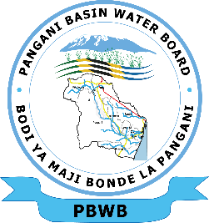

November 2024 – October 2025
Annual Hydrological Report

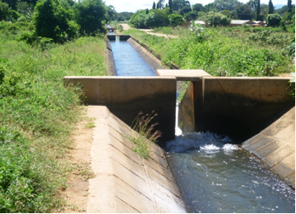

Pangani Basin Water Board
P.O Box 7617
Moshi
Email: basins.pangani@panganibasin.go.tz
basins.pangani@maji.go.tz
Website: www.panganibasin.go.tz
Phone:+255 (27) 2752780/2752727
+255 739 120400
November, 2025

EXECUTIVE SUMMARY

Pangani Basin is located in the North Eastern of the United Republic of Tanzania within latitudes 3⁰ 03’S and 5⁰ 59’S; and longitudes 36⁰ 23’E and 39⁰ 13’E covering an area of about 58,400 km², whereby 54,600 km² (93%) falls within the United Republic of Tanzania and the remaining 3,800 km² (7%) lies in the Republic of Kenya. The Basin is a host of important features such as Mt. Kilimanjaro (5895m above mean sea level) and Mt. Meru (4566m above mean sea level) which borders the Basin to the North, the Pare and Usambara Mountains to the North-East, and encompasses the Simanjiro and Kitwai Plains to the South-West. The Lowlands (up to 900m above mean sea level) make up about 50% of the Basin area.
This hydrological review, which also provides an overview of water resources status throughout 2024/2025, was undertaken as part of the Basin Hydrological Monitoring and operation. A primary source of information for this review is the series of daily, monthly and quarterly monitoring data collected from stations strategically installed in the Basin.
The Basin experiences a bimodal type of rainfall pattern which receive two seasons annually occurring in March-June (long rains/masika) and October-December (short rains/vuli). The rainfall patterns are largely controlled by altitude wherebythe highlands receive about 1000-2000 mm/year while the lowlands receive between 500-600mm/year. In 2024, the data show high inter-annual variability in rainfall in the basin (coefficient of variation > 30% for 18 stations out of 37 used for assessment. 5 stations show increasing trends (annual and seasonal), but others (especially for the "vuli" season —) show decreasing trends. The average release flow of the Pangani River at the Nyumba ya Mungu Dam reacorded in 2024 was higher compared to the previous three years (2022–2024) from January through November.
Given its dependence on rainfall influenced by seasonality of precipitation, it is likely that groundwater levels in shallow aquifers rise during the rainy seasons and fall in the dry season — similar to what is observed in many tropical, semi-arid basins. Areas with intensive groundwater extraction (e.g., for irrigation) are more likely to show declining trends, especially if recharge is not keeping up with abstraction. However, the report also highlights that groundwater potential is insufficiently assessed since there is no a comprehensive study condutected related to aquifer potential and sustainable management scenarios. Also, the Basin is transboundary hence part of its aquifers are also crossing the coutry boarders making a complex) management options. Local studies (Komakech & de Bont) note that over-exploitation in parts of the basin is leading to declining groundwater levels in some areas

FOREWORD


The release of this Annual Hydrological Report is a part of the main function of the Pangani Basin Water Board which is mandated through the Water Resources Management Act, No.11 of 2009, to ensure there is sustainable management of Water Resources within the Basin area covering the administrative Boundaries of the parts of Kilimanjaro, Arusha, Tanga and Manyara Regions (Simanjiro and Kiteto districts) . This report provides a clear overview of the status of water resources in catchments of Kikuletwa, Pangani, Ruvu, Luengera, Umba and Zigi which in particular their waters play a great role in the social-economic development of the Basin’s population. The analysis was carried out by comparing current data to the long-term averages across various variables that representing the water cycle.

This report’s preparation relied heavily on observed data from hydroclimatic station both manually operated and, in some cases, remotely sensed data especially for groundwater and evapotranspiration in order to ensure broader basin coverage and addressing the data gaps. This report does not involve any ground-based observation data from any other Agency or Authority across our Basin which in any case may be operating similar station for other purposes and in particular they could reveal different result from what has been observed by our monitoring stations. However, we encourage data sharing and engagement of other Agencies and Authorities toward achieving a uniform report based solely on hydrological observations for the later editions of this kind of the report.

The Board will continue to allocate resources towards investing in monitoring and assessment of the available water resources within the basin and keep these reports available to the public so that to keep proper records on the professionally analyzed annual water data and enhance their availability. We call upon collaboration with all interested parties/partners within and outside the basin to protect the water resources and invest on infrastructures, especially monitoring stations to ensure sustainable quality and quantity of water resources.

Currently the Basin targets to prepare and implement an ‘Integrated Water Resources Management and Development (IWRMD) Plan’ which will provide information of available water resources and demand by sector-wide approach. Also, the plan will act as a blueprint to all stakeholders in the in sustainable water resources management especially during preparation of the water using plans. Among other benefits, the Plan usage will minimize water related challenges like managing the impacts of climate change; managing droughts and floods; addressing the water use conflicts and water sources degradation.

Segule Segule A.
Basin Water Director

LIST OF ABBREVIATIONS

MCM Million Cubic Meter
DTM Digital Terrain Model
MAP Mean Annual Precipitation

TABLE OF CONTENTS
EXECUTIVE SUMMARY ii
FOREWORD iii
LIST OF ABBREVIATIONS iv
TABLE OF CONTENTS v
1. GENERAL INTRODUCTION 1
1.1 Background 1
1.2 Location and Administrative Units of the Basin 2
1.3 Physiography 3
1.3.1. Topography 3
1.3.2. Geomorphology 4
1.3.3. Drainage Patterns 4
1.4 Soils 5
1.5 Land Use and Land Cover 5
1.6 Geology 7
1.7 Main Features in the Basin 7
1.8 The Purpose and Objectives of the Annual Hydrological Report 7
2. HYDROLOGICAL NETWORK USED IN THIS REPORT 8
2.1. Rainfall Stations 8
2.2. River Gauging and Reservoir Monitoring Stations 8
1.9 Water Quality and Pollution Control Stations 9
2.3. Groundwater Stations 10
3. HYDROLOGY OF THE BASIN AND CURRENT WATER STATUS 11
3.1. Rainfall/Weather 11
3.2. River flows 12
3.3. Water Storage 14
3.3.1 Lakes 14
3.3.2 Dams 15
A. Nyumba ya Mungu Dam 15
B. Mabayani Dam 16
C. Kalimawe Dam 16
3.4. Sediment 17
3.5. Groundwater 17
3.6. Water Quality and Pollution Control 18
4. CONCLUSION, RECOMMENDATION AND CHALLENGES 21
4.1 Conclusion 21
4.2 Recommendation 21
4.3 Challenges and Intervention 21
5. ANNEXES 22
5.1 Strategic location of Water Quality Stations 22
5.2 Rainfall Station Summary 22
5.3 Meteorological/Weather station Summary 23
5.4 River Gauging Stations Summary 23
5.5 Groundwater Monitoring Stations 25

GENERAL INTRODUCTION

  - Background
Pangani Basin is one of the nine hydrological basins in Tanzania. It drains an area of approximately 58,400 sq km of which 93% equivalent to 54,600 Km² lies on the Tanzania side and the remaining 7% equivalent to 3,800 Km² lying in the Kenyan side. and 7% is in Kenya hence making it one of the Seven transboundary Basins in Tanzania which share its water resources with neighboring countries of Tanzania and Kenya specifically catchments of Lake Chala, Jipe and Umba River. Within Tanzania, the Basin extends from the highlands around Mount Meru and Mount Kilimanjaro through to the Pare and Usambara ranges reaching the lowlands of Simanjiro. The administrative regions within the Basin are Arusha, Kilimanjaro, Tanga, and Manyara (Simanjiro and Kiteto Districts). The Basin hosts a total of 24 District Councils.
The basin is also important to the Tanzanian economy, playing a central role in supporting national food and energy security. It is also the second largest producer of food in the country and it plays a major role in supporting rural livelihoods through subsistence and commercial agriculture. The region is also a home to a number of commercial agriculture producers such as coffee and sugar. Also, it has the largest concentration of horticulture and floriculture producers in the country with over 30 companies in the region identified as exporting to European markets alone.( Pangani River System: State of the Basin Report – 2007) Together these play a major role in ensuring both domestic food security and export earnings. Evidence suggests there could be around a million herds of cattle in the basin which significantly increases water demand. .( Pangani River System: State of the Basin Report – 2007)
The basin also plays an important role as an energy producer with installed capacity providing 97 MW equivalent to 17% of Tanzania’s national power output from its three hydropower plants installed with the Pangani River system, namely Nyumba ya Mungu – 8MW, Hale – 21MW and New Pangani Falls – 68MW. This makes it the second largest contributor to grid connected energy in the country, after the Rufiji Basin.
Due to high water demand catalyzed by awareness on the economic benefits of water and insufficient management plans, water related conflicts are also high compared to other Basins. Likewise, water resources in particular and the environment in general are increasingly degraded due to growing human population, poor land management plans, poor mechanism and practices of farming, livestock keeping, artisanal mining, etc. These water resources management related challenges in various areas of the Basin, may affect the smooth implementation of both national and international agendas such as Development Vision 2050 and Sustainable Development Goals of 2030.
  - Location and Administrative Units of the Basin
The Pangani Basin (Figure 1.1) is located between latitudes 3⁰ 03’S and 5⁰ 59’S; and longitude 36⁰ 23’E and 39⁰ 13’E in the North Eastern Tanzania. Pangani Basin Water Board (PBWB) was established in July, 1991 in accordance with the Water Utilization (Control and Regulation) Act No. 42 of 1974 through its subsequent amendments of 1981 followed by gazettement of the nine Basin Water Boards in October 1989. The former Act was repealed by Water Resources Management Act No. 11 of 2009. The headquarters is located in Moshi along Old Moshi Road/Pangani Street. There are also two Catchment Water Offices (Sub-offices) one is the Kikuletwa-Ruvu Catchment with offices in Arusha along Wachaga Road and the second is Zigi-Umba Catchment located in Tanga along Gofu Area Street. Both offices are led by Catchment Incharges..

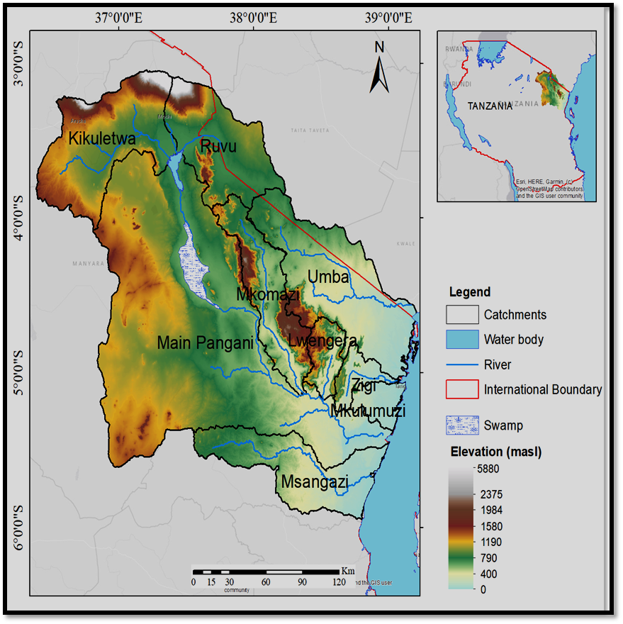
Figure 1.1:The map showing location of the Pangani Basin and its catchments
  - Physiography
    - Topography
In the North Western part, the basin hosts Mount Kilimanjaro (5,895m above mean sea level) which is the highest mountain in Africa and Mount Meru (4,566m above mean sea level) found within Kikuletwa Catchment. The two mountains make the water towers of the Basin and Kikuletwa catchment in particular from which originates tributaries forming the Kikuletwa River with an average flow of 11.502 m3/s while on the North eastern form Ruvu River with an average flow of 5.339 m3/s which originates from Lake Jipe. Mkomazi River with average flow of 0.510m³/sec and Luengera River with average flow 1.333m³/sec flows from Pare and Usambara Mountains respectively to the Main Pangani River. Pare and Usambara Mountains are found to the north and north-east while the Simanjiro and Kitwai Plains encompasses the Basin to the south-west (Figure 1.2). Lowlands (of up to 900m above mean sea level) make up about 50% of the Basin area.

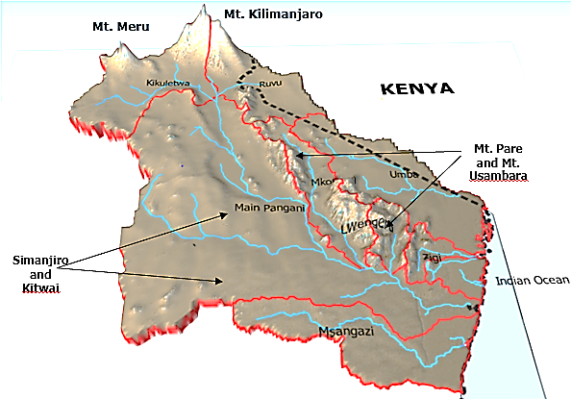
Figure1.2: Digital Terrain Model (DTM) showing Topography and Rivers
    - Geomorphology
Pangani Basin has great diversity ranging from ocean beaches in the east to the volcanic peaks in the north. Different landscapes are as well observed in between these. Five geomorphological structures can be identified: the coastal zone, the Pare and Usambara Mountains, the Kilimanjaro and Meru Mountains and the tectonic valleys.
    - Drainage Patterns
Hydrologically, the Basin is divided into five sub-basins based on the main watershed boundaries which are Pangani, Msangazi, Zigi, Mkulumuzi and Umba. These rivers have independent sub-basins and with each one draining its water to the Indian Ocean. Furthermore, nine catchments have been identified based on the catchment boundaries related to particular rivers which are Kikuletwa, Ruvu, Pangani Mainstem, Mkomazi, Luengera, Msangazi, Zigi, Mkulumuzi and Umba. The Pangani River which is the largest and longest of all rivers within the basin originates from Nyumba ya Mungu Dam. The dam is located at the foot of the Kikuletwa and Ruvu catchments and collects water from the two catchments. They receive water from two main rivers of Kikuletwa with long-term average flow of 10.295m³/sec and the Ruvu which flows at the average of 2.612m³ /sec. The Nyumba ya Mungu reservoir is the largest inland water body within the Basin and the 2nd in the country with a surface area is about 140 km² at normal storage and 162km² when its full to the extent of spilling. The reservoir has a maximum carrying capacity of 1.1 billion cubic meters and spills when reaches 688.91 m.a.s.l. Other water bodies are lakes which include Chala, Jipe, Duluti, Manga, Momela and Karamba while Mabayani, Horohoro and Kalimawe dams are man-made reservoirs.
The Basin is also endowed with high potentials for groundwater which enhance the conjunctive use of both surface and ground water for both social an economic use mainly domestic, energy (HEP) and irrigation purposes. About 5% of all the water used in the Basin is derived from groundwater sources of which the highest yield recorded so far from the water wells is 600m³/h from boreholes drilled at TPC sugarcane farm in Ruvu catchment from the alluvium deposits aquifer found between 30 meters and 80 meters. The high groundwater potential aquifers are also being found within Majimoto area (Hai District), Valeska-Mbuguni (Arumeru District) and Seed Farm (Arusha District) in Kikuletwa catchment. The boreholes yield up to 400m³/h from the confined aquifer found between 80 meters and 240 meters.
  - Soils
The soil type ranges from sticky volcanic soils within the peaks of Mts. Kilimanjaro and Meru, redish lateritic soils within Pare and Usambara Mountains, mbuga clays and black cotton soil in plains like Kitwai and sandy soils in coastal zones. The vegetation includes heavy forests in mountainous areas (Meru, Kilimanjaro, Pare and Usambara being good examples) and grasslands as observed in lowlands Kitwai and Simanjiro are good examples.
  - Land Use and Land Cover
Land use in the basin is governed primarily by rainfall but also by soils and availability of surface water. The mountainous areas and coastal lowland areas have the highest rainfall. The highlands are particularly favored for coffee, wheat, bananas, flowers and vegetables. The mountain foothills and lowlands are used intensively for cultivation of crops such as rice, sugarcane, bananas, maize, tomatoes, beans, millet, sorghum, groundnuts and onions. Agriculture in the Basin is rain fed and irrigated utilizing reservoirs and traditional/improved furrows abstracting water from different sources. There are both subsistence and commercial farming in the Basin.
The main water use economic activities are irrigation, hydropower generation, mining, industry, livestock keeping, recreation and small-scale fishing. The Basin is also a home of 4 National Parks (Kilimanjaro, Arusha, Saadani and Mkomazi); and Controlled Areas (Amani Nature Reserve) which is used for wildlife as well as tourism and many water sources are hosted from these areas. Dairy farming (using a zero-grazing system) is rampant throughout the mountain areas of Meru, Kilimanjaro, Pare and Usambara while open grazing is common in lowlands like Kitwai, Simanjiro and Handeni.
The Basin is also rich in minerals and gemstones which attract mining activities of the most famous gemstones found in the basin include Tanzanite (which is only found in Tanzania) and other minerals includind gold, ruby, anyolite, corundum, rhodolite, green garnets, red garnets, sperssartite, tourmaline, emeralds, sunstones, moonstones, aventurine quartz and aquamarine.
The land cover of the Basins is characterized by cropland, dense forest, rangeland, bare ground, builtups water bodies and snow cover. The snow cover is mainly attribute to Mount Kilimanjaro scow cap. The dense forest is also attributed to slopes of Kilimanjaro, Meru, Pare and Usambara Mountains while Most of the lowlands are semi-arid characterized by Cropland and Rangeland. Some of the water bodies are now covered by invasive species of water weeds (flooded vegetation in the map), examples being the Lake Jipe and the uptakes of the Nyumba ya Mungu Reservoir.
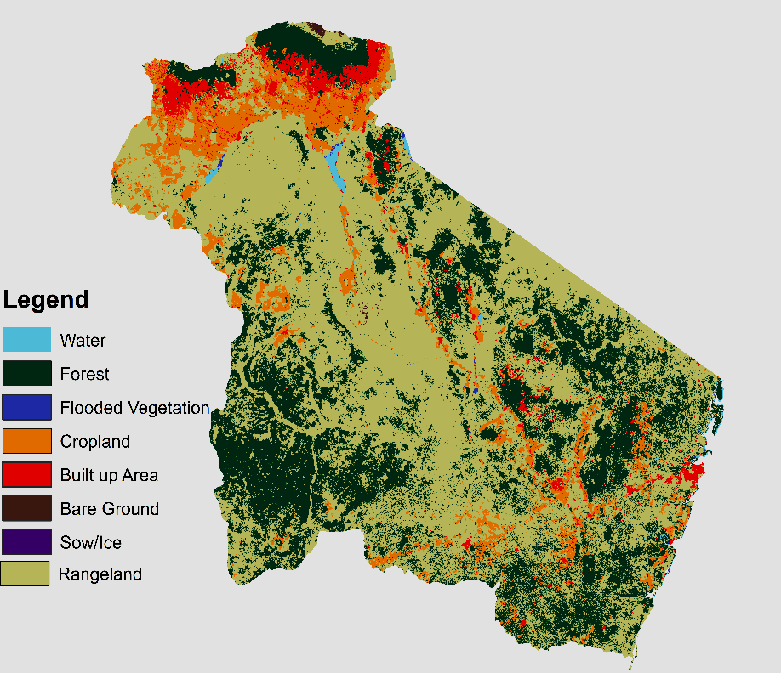
Figure 1.3: The Land Cover Distribution of the Pangani Basin for year 2023
(Source: https://livingatlas.arcgis.com/landcover/ Accessed on: 24 December,2024)
  - Geology
The geology of the Basin is composed of Precambrian rocks (gneisses, marble, schist, amphibolite, etc) assigned to the Usagaran System. These are common in Pare and Usambara Mountains and also form the basement in lowlands. Neogene volcanic predominate the Mt. Kilimanjaro and Mt. Meru areas. Karroo sediments are found in north of Tanga. There are Cretaceous Limestone in Tanga which raw material for cement industry and recent coastal sands are found all along the cost. Alluvial sediments together with lacustrine deposits are located in patches all over the Basin and this form part of discrete aquifer observed in the Basin.
  - Main Features in the Basin
The Basin is characterized or dominated by the presence of high peaks of the country; the Mount Kilimanjaro (5895m above mean sea level), Mount Meru (4566m above mean sea level) and the Pare and Usambara Mountains to the north and north-east while the Simanjiro and Kitwai Plains encompasses the Basin to the south-west. Lowlands (of up to 900m above mean sea level) make up about 50% of the Basin area.
  - The Purpose and Objectives of the Annual Hydrological Report
The Management of water resources require information from collected data that will enable planning, development and decision making in a sustainable manner. This Annual Hydrological Report is a statistical report that presents information from various sources to be used as a guide to planning and decision making. The Report is the basic requirements for the Basin to manage its water resources adequately and it is representing a complete information system for water availability and water use record in a particular year

HYDROLOGICAL NETWORK USED

The Water Resources Monitoring network in the Basin consist of 59 river gauging stations, 6 lake/reservoir gauging stations, 11 groundwater stations, 15 weather stations, 37 rainfall stations, 64 water quality stations and 44 pollution control stations. Also, Basin collaborates with other institutions to exchange and share information/data and currently have access to obtained groundwater data from 24 stations owned by NM-AIST, 65 stations owned by TPC Ltd and 10 stations owned by 3 councils (Moshi Municipal, Tanga City and Arusha City). These stations are operated either manually, semi-automated (installed with loggers) or both manually and automated. Data collection is done in the field (data downloading by staff during field visit and recorded daily (water levels) by gauge readers or met observers. Water quality and pollution control stations are only operated manually.
Hydrological data from stations which are collected, analyzed, stored and disseminated include surface water, groundwater levels, water quality and pollution control, and water use information. Surface monitoring network composed of river gauging, meteorological and rainfall stations while groundwater network is composed of monitoring boreholes

2.1. Rainfall Stations
In this reporting period data from 18 rainfall/weather stations have been used to derive the rainfall status within this hydrological year being reported. Their distribution is as illustrated in the map in Figure 4.

2.2. River Gauging and Reservoir Monitoring Stations
In this reporting period there are 59 river gauging stations and among them five representative stations have been selected to derive the water status in major rivers of the basin including Pangani, Zigi, Ruvu and Kikuletwa rivers. Again, this report also analyses monitoring data carried in the Nyumba ya Mungu and Mabayani reservoirs only, being the major reservoir found within the Pangani Basin. The below map illustrates the location of the river and reservoir gauging station used in this reporting period

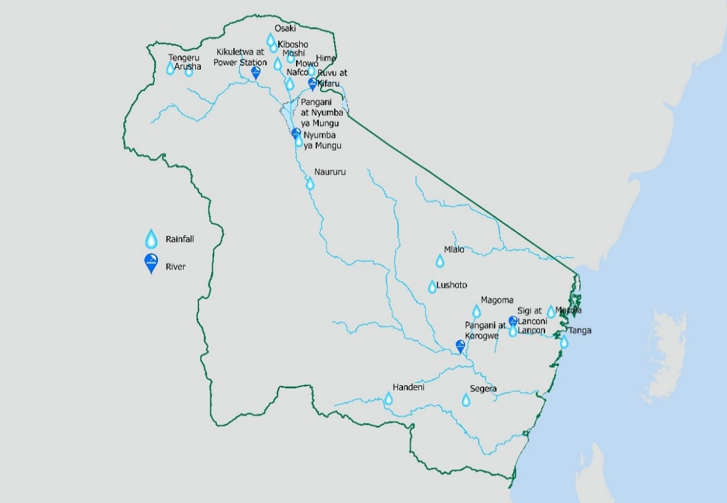
Figure 1.4: A map of Rainfall and river gauging stations with data in this report
  - Water Quality and Pollution Control Stations
There are 108 stations for Quality and Pollution Control Monitoring Network; where 64 stations are for water quality and 44 stations are for effluent monitoring which are designed to collect data at least once quarterly. Nine (9) of these water quality monitoring station have been selected to be representative in this report as shown in the figure below.

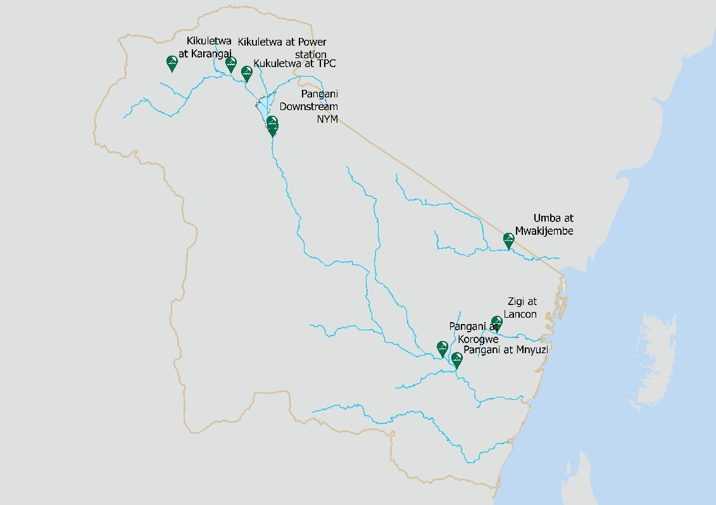
Figure 1.5: Distribution of Water Quality monitoring station with data in this report

2.3. Groundwater Stations
Basin has 11 working groundwater monitoring boreholes network distributed in Tanga, Kilimanjaro and Arusha regions as follow: Arusha – 3 monitoring boreholes at Sinoni, Magereza and Kambi ya Tanga; Kilimanjaro – 5 monitoring boreholes at Magereza, Sanya Juu, Sido, Kaloleni, and Mabogini; and Tanga – 3 monitoring boreholes at Makayo, Pangani and Korogwe. Also Basin in collaboration with Nelson Mandela African Institute of Science and Technology (NM-AIST) and TPC Ltd has managed to access groundwater data from 24 and 65 monitoring stations respectively. The figure below shows the position of the Pangani Basin monitoring boreholes used in this report.

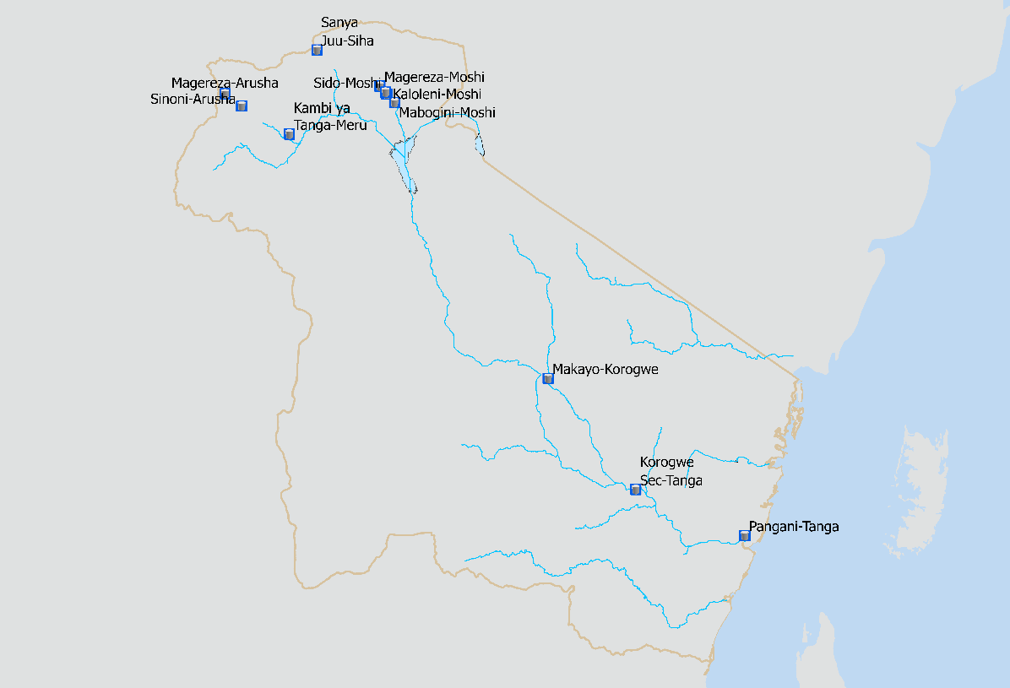
Figure 1.6: Distribution of Groundwater Monitoring Stations used in this report

HYDROLOGY OF THE BASIN AND CURRENT WATER STATUS
  - Rainfall/Weather
Generally, rainfall in the basin is bimodal. Rainfalls are categorized in two periods; long rains occurring in March-June and short rains October –December. Rainfall patterns are largely controlled by altitude; the highlands receive more rains about 1000-2000mm per annum while the lowlands receive rains between 500-600mm per annum.
The data collected from 31 representative rainfall and met stations in the basin have been categorized using the agreed criteria of percentage Mean Annual Precipitation (%MAP). These categorization as follows;
- Less than 75% regarded as Dry,
- Ranging 75-125% regarded as Average and
- Greater than 125% regarded as Wet.
Table 3.1 was developed based on those categorization.
General distribution of rains in the basin were not even although most of the areas in the basin ranged from dry to average except in few stations (6 stations) were wet. The table and figure below shows Annual Monthly Rainfall for the period Nov 2024-Oct 2026
Table 3-1: Annual Monthly Rainfall (2024/2025)
Month | Rainfall Station
Month | Maji | Tengeru | Himo | Kibosho | Mowo | Nafco | Naururu | NYM | Osaki | Moshi | Magoma | Lancon | Segera | Tanga | Mazola | Mlalo | Lushoto | Handeni
Nov | 3 | 106 | 74 | 53 | 116 | 27 | 50 | 86 | 93 | 26 | 27 | 45 | 45 | 7 | 37 | 63 | 117 | 210
Dec | 530 | 388 | 149 | 412 | 218 | 102 | 517 | 54 | 417 | 137 | 159 | 341 | 341 | 16 | 215 | 264 | 648 | 326
Jan | 51 | 83 | 58 | 146 | 181 | 26 | 66 | 90 | 202 | 80 | 56 | 91 | 91 | 4 | 5 | - | 229 | 238
Feb | 24 | 39 | 10 | - | 26 | - | 4 | - | 18 | 6 | 45 | 1 | 1 | 0 | - | - | 39 | 104
Mar | 120 | 361 | 371 | 416 | 385 | 241 | 418 | 152 | 184 | 302 | 77 | 108 | 108 | 9 | 30 | 83 | 163 | 275
Apr | 296 | 642 | 167 | 910 | 771 | 92 | 74 | 185 | 612 | 478 | 100 | 120 | 120 | 33 | 240 | 123 | 365 | 223
May | 178 | 448 | 73 | 1,058 | 527 | 43 | 19 | 6 | 930 | 138 | 179 | 86 | 86 | 22 | 116 | 50 | 94 | 446
Jun | 19 | 83 | 26 | 290 | 167 | 5 | 2 | 1 | 246 | 34 | 63 | 90 | 90 | 5 | 160 | 92 | 19 | 212
Jul | - | 19 | 9 | 192 | 65 | - | - | - | 146 | 11 | 5 | 12 | 12 | 1 | 22 | 18 | 0 | -
Aug | - | 6 | 5 | 20 | 36 | - | - | - | 80 | 6 | 5 | 18 | 18 | 2 | 30 | 4 | 6 | -
Sep | - | - | - | 1 | - | - | 21 | - | - | - | 11 | 37 | 37 | 0 | 16 | 5 | 1 | -
Oct | 3 | 42 | 41 | 119 | 124 |  | 23 | 76 | 147 | 17 |  | 168 | 168 | 11 | 185 | 107 | 61 | 81

Therefore this average trends situation has caused some decreased in river levels and flows, decrease crop production, unstable hydropower production, slightly increase in water use conflicts and decrease water levels fluctuation in production boreholes.

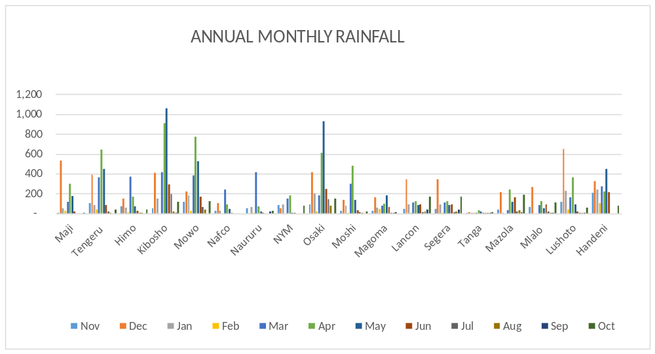
Figure 3.1: Trend of Annual Monthy Rainfall
  - River flows
The Pangani Basin has two main headwater rivers feeding the large reservoir Nyumba ya Mungu Reservoir, the Kikuletwa River and Ruvu River. The Ruvu supplying water to Nyumba ya Mungu effectively forms part of the upstream of the main Pangani River (after the dam). The source of (this) Ruvu in the Pangani system is from Lake Jipe and surrounding catchments (including areas influenced by northern slopes of mountains like Mount Kilimanjaro). Ruvu via Lake Jipe and its catchment is critical source for the Pangani Basin’s water supply, hydropower, irrigation and downstream flow. The average flow of Ruvu (as feeding Nyumba ya Mungu) is this year was 13.613m3/s above the average as 5.339 m³/s in this hydrological year (2024/2025). The upstream tributary Kikuletwa (which helps feed the Pangani via Nyumba ya Mungu) has peak flow of 31.613 above the long-term average flow upstream of the dam 11.502 m³/s. Long-term (historical) discharge for Pangani at Korogwe station shows mean monthly flows roughly ranging from 22 to 39 m³/s depending on month.
In 2024/2025 at the main upstream regulator Nyumba ya Mungu Dam (Nyumba ya Mungu reservoir / station) the “release flow of Pangani River was higher compared to three years (2022-2024) for the period January–November 2024. Downstream ecological/hydrological studies for Pangani (post-reservoir years) suggest that for most of the year flows downstream remain in the ≈ 20–40 m³/s range. The the inflow to Nyumba ya Mungu reservoir from its two main tributaries Kikuletwa River and Ruvu River is 43.37 m³/s on average.
Zigi River is part of the Pangani Basin, which also includes the main stem Pangani River, the Kikuletwa River, and others. Historically, the hydrological station at “Lanconi Estate” (≈ 10 km above the downstream dam) measured monthly flows for Zigi. In wet season the Zigi river flows was 6.5m³/s that is above the monthly average flow (3.4m³/s).
More broadly for the Pangani Basin: surface runoff and river flows across many tributaries (including coastal rivers like Zigi) have been under stress due to increased abstraction (irrigation, hydropower), land-use changes (deforestation) and climate variability.
Some selected river gauging stations were given priority of making sure they provide reliable and accurate data. In May 2025, eleven (11) river gauging station (Table 3-2) were visited for the purpose of high discharge measurement, generating/ updating the rating curves and assessment of surface water quality. The results show the increase of surface water flows due heavy rainfall as observed to some stations in Pangani River Catchment.
Table 3-2: The results of high flow measurement
No. | River | Location | Station ID | Staff gauge (m) | Discharge (m³/s)
1. | Weruweru | Railway Bridge | 1DD5B | 1.50 | 11.992
2. | Himo | Himo Bridge | 1DC11 | 1.08 | 7.209
3. | Karanga | Karanga bridge | 1DD3 | 1.80 | 19.330
4. | Kikafu | Kikafu Bridge | 1DD8A | 1.35 | -
5. | Kikuletwa | Power station | 1DD54 | 1.90 | 29.853
6. | Kikuletwa | TPC | 1DD1 |  | 31.613
7. | Ruvu | Kifaru Bridge | 1DC54 | 1.65 | 13.101
8. | Pangani | Naururu | 1D18 | 1.45 | 48.432
9. | Pangani | Nyumba ya Mungu | 1D8C | 2.40 | 78.453
10. | Pangani | Korogwe | 1D14 | 1.2 | 11.502
11 | Zigi | Lancon | 1C2 | 2.6 | 23.34

Figure 3.2: Flow hydrographs for selected gauging stations
  - Water Storage
    - Lakes
There are three large lakes existing within the basin. These are Chala, Jipe and Duluti. Detailed of these dams are summarized in the Table 3-3 below.

Table 3-3: Information of major lakes in the basin
S/No. | Lake | Area | Depth (m) | Volume (m³)
1 | Lake Chala | 421 ha | 90 | 340,000,000
2 | Lake Duluti | 0.7 km² | Average 4 (maximum 8) | 2,400,000
3 | Lake Jipe | 4047 ha | 2 – 3 | 81,000,000
    - Dams
There are three large dams existing within the basin. These are Nyumba ya Mungu, Mabayani and Kalimawe dams. Details of these dams are summarized below:
- Nyumba ya Mungu Dam
Water level in the Nyumba ya Mungu dam is affected by rainfall and runoff situation in upstream catchments (Kikuletwa and Ruvu). One can even tell water resources situation in the Basin by just analysing flows at Nyumba ya Mungu Dam. Average net inflow into Nyumba ya Mungu dam (calculated) in year 2024/2025 is 43.58 m³/s compared to Long term (1993-2019) mean annual net inflow is 21.63 m³/s. Water level in the week no. 44 (1st November 2024) is 684.91 metre above sea level. This level is above minimum water level for hydropower generation (683.35 masl) by 1.56m (see figure 3.7 below). In year 2023 for the same week, water level was 687.65 masl. This conclude that year 2024/2025 is dry to average in terms of water availability.

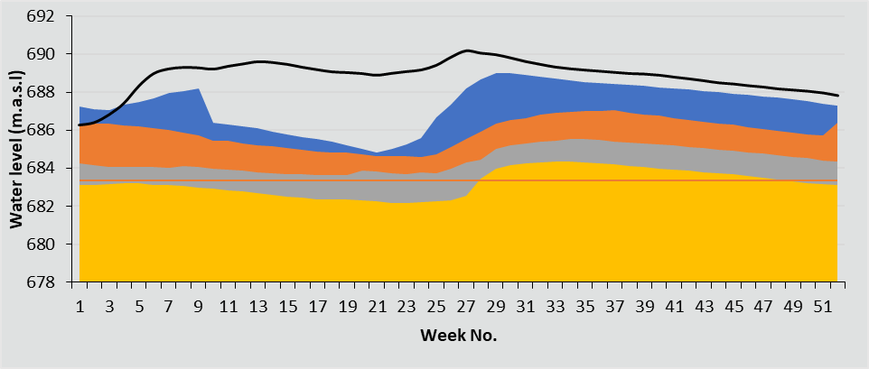
Figure 3.3: Nyumba ya Mungu Dam water levels for 2024/2025
Note:
Highest water level (HWL) in Nyumba ya Mungu Dam is 688.91m asl (871.74 MCM). Lowest hydropower operational level is 683.35m asl (249.75 MCM) and lowest water level (LWL) is 679.15m asl.

- Mabayani Dam
Zigi River is the main source of Mabayani Dam which originates from Usambara Mountain and supply water to Tanga City and nearby areas. It is managed by Tanga Urban Water Supply and Sanitation Authority and has storage capacity of 7.7 Mm³ (of which live storage is 5.3 Mm³). Water level trend (water levels fluctuation) for year 2024 and 2025 in 10 months (Nov – Aug) shown in Figure 3.4 where water level fluctuation in 2024 and 2025. This situation caused by little rainfall (VULI) received in Zigi catchment.

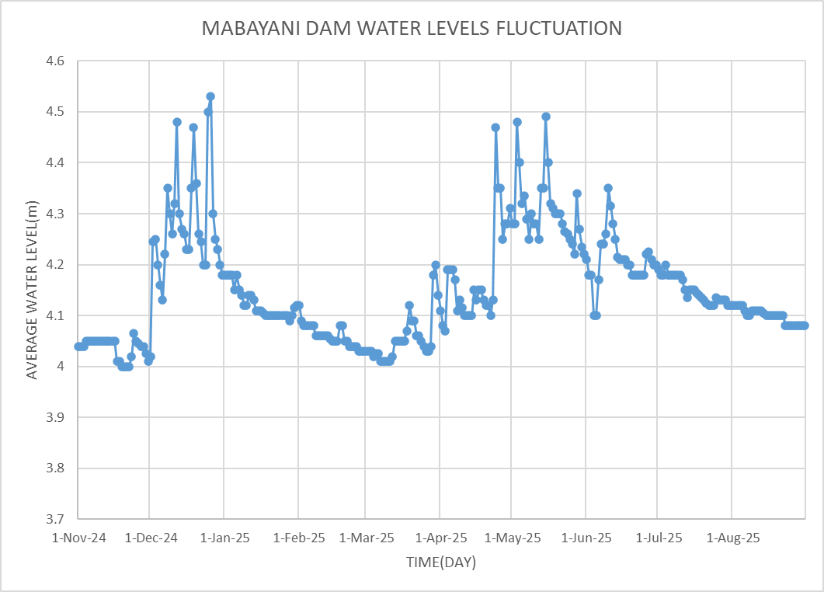
Figure 3.4: Mabayani Dam water levels for year 2024/2025
- Kalimawe Dam
Mkomazi River is the main source of Kalimawe Dam which originates from Pare Mountain and supply water to Ndungu Irrigation Scheme in Same District and other users nearby areas. The dam is non-function due to siltation problem and other infrastructures not work properly i.e. gates, monitoring devices, etc. Detailed of the dam is summarized in the table 3.0-3 below:

Table 3-4: Information of major lakes in the basin
Storage of the Dam (m³) | 6,075,000
Average Depth of the Dam (m) | 5
  - Sediment
Sediment transportation accelerated by surface runoff caused by improper land use management such as deforestation, poor farming practices and human settlement near water courses. Measurements of sediment monitoring as sediment load was not performed in this reporting period.
  - Groundwater
Groundwater level data collected in this annual hydrological year shows that water level fluctuation is slightly significant in 4 out of 11 monitoring stations from November 2024 to October 2025. Groundwater monitoring stations status are shown in table 3-4 below. Trend of water level is quite good with slightly fluctuation. Seven (7) out of 11 monitoring stations water levels fluctuation are almost the same (see table 3-5 below and figure 3.9). Generally, the water level records from these boreholes seem to be stable with slightly fluctuation observed.

Table 3-5: Quarterly water level fluctuation from ground level
No | Station Name | Nov-24 | Dec-24 | Jan-25 | Feb-25 | Mar-25 | Apr-25 | May-25 | Jun-25 | Jul-25 | Aug-25 | Sep-25 | Oct-25
1 | Sanya Juu | 6.01 | 6.18 | 6.23 | 6.22 | 6.25 | 5.67 | 5.39 | 5.11 | 5.25 | 5.39 | 5.67 | 5.53
2 | Magereza-Moshi | 26.45 | 26.51 | 26.50 | 25.33 | 25.33 | 25.17 | 25.09 | 25.01 | 24.60 | 24.19 | 23.36 | 23.77
3 | Kaloleni | 7.51 | 7.62 | 7.03 | 6.64 | 6.46 | 6.92 | 6.73 | 7.19 | 7.23 | 7.27 | 7.34 | 7.30
4 | Mabogini | 6.17 | 6.22 | 6.22 | 6.19 | 6.17 | 6.23 | 6.25 | 6.27 | 6.30 | 6.34 | 6.40 | 6.37
5 | Sido | 15.39 | 15.71 | 15.68 | 15.22 | 14.48 | 14.87 | 14.58 | 14.51 | 14.62 | 14.73 | 14.94 | 14.83
6 | Magereza-Arusha | 42.80 | 42.80 | 42.66 | 42.57 | 42.42 | 42.56 | 42.55 | 42.67 | 42.54 | 42.41 | 42.15 | 42.28
7 | Sinoni | 1.20 | 0.98 | 0.97 | 0.94 | 0.86 | 0.84 | 0.82 | 0.78 | 0.80 | 0.81 | 0.84 | 0.83
8 | Kambi ya Tanga | 13.22 | 13.13 | 13.09 | 12.97 | 12.92 | 12.82 | 12.71 | 12.50 | 12.57 | 12.64 | 12.77 | 12.70
9 | Makayo | 0.00 | 0.00 | 0.00 | 0.00 | 0.00 | 0.00 | 0.00 | 0.00 | 0.00 | 0.00 | 0.00 | 0.00
10 | Pangani | 26.06 | 26.06 | 26.01 | 25.73 | 25.65 | 25.38 | 25.21 | 25.03 | 24.71 | 24.40 | 23.76 | 24.08
11 | Korogwe | 7.10 | 7.10 | 6.99 | 6.94 | 6.82 | 6.55 | 6.36 | 6.15 | 6.39 | 6.63 | 7.11 | 6.87

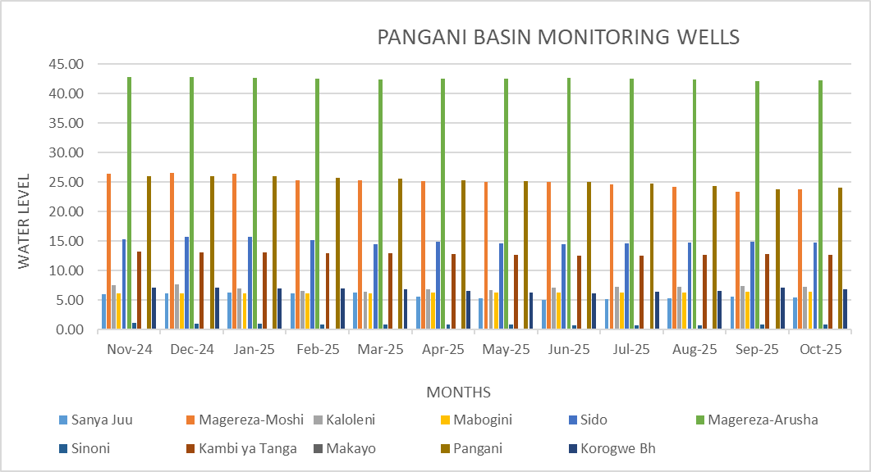Figure 3.5: Quarterly ground water level fluctuation
  - Water Quality and Pollution Control
Water quality management and pollution control were conducted in 108 stations (64 water quality monitoring and 44 pollution monitoring) located in Arusha, Kilimanjaro, Manyara and Tanga regions where as samples were collected at 47 stations of water quality and 20 stations of pollution monitoring.
Various physical parameters such as pH, Colour, Temp, EC, TDS, Turbidity and Chemical parameter of Dissolved Oxygen, Nitrate, Phosphate, Chloride, Fluoride, Total Suspended Solids, Total Hardness, Calcium, Manganese, Biochemical Oxygen Demand, Chemical Oxygen Demand, Sulphate and Fecal and Total Coliform (biological parameter) are used in measuring and assessing water quality status. Water quality Assessment were carried out by comparing them with Guidelines and Standards which are Natural Range of Water Quality from Monitoring Guidelines for Water Resources Pollution Control of 2012, Tanzania Standard for receiving water Bodies (TZS 2068: 2017-Category 2) and East Africa Standard for Portable Natural Water (EAS 12:2018).
One hundred percent (100%) of the samples tested for Turbidity, Sulphate, and Fluoride comply with Natural Range of Water Quality while pH complies by 88.4%, Color by 92.3%, Electrical Conductivity by 73%, Chlorides by 21.3%, and Biochemical Oxygen Demand (BOD) by 69.2%. Phosphate and Nitrate were above the natural water quality range in all 47 samples tested.

On the other hand, 100% of the samples tested for TDS, Chloride, Fluoride, Manganese and Sulphate comply with Tanzania Standard for Receiving Water Bodies while pH complies by 91%, BOD by77 %, Nitrate by 95%.
With respect to the East Africa Standard for Natural Portable l Water (EAS 12:2018)100% of the samples tested for pH, EC, TDS, Chloride, and Sulphate comply with the standards, while Color complies by 67%, Turbidity by 72%, Nitrate by 95%, Phosphate by 4%, and Fluoride by 50%. Additionally, there were indicators of fecal contamination (Total and Fecal Coliforms) in all 47 samples tested and E. coli were found in only one station.
Noncompliance of some of the tested parameters may be attributed to the increase of anthropogenic activities in the uplands that leads to carrying of nutrients to the rivers.
The stations analyzed includes eight designated locations of Kikuletwa River at Karangai, Kikuletwa River at Power Station. Kikuletwa River at Power station, Pangani River d/s Nyumba ya Mungu Dam, Pangani River at Mnyuzi, Ruvu River at Kifaru, Umba River at Mwakijembe and Zigi River at Lanzoni. The figure below shows the highest parameters recorded.

Figure 3.6: The highest parameters recorded
No | Parameters | Unit | Standards/Guidelines Used
No | Parameters | Unit | A | B | C
1 | Chloride | mg/l | <10 | 200 | 250
2 | Nitrate | mg/l | 0.1 | 50 | 45
Table 3.6: The standard/guideline of parameters recorded
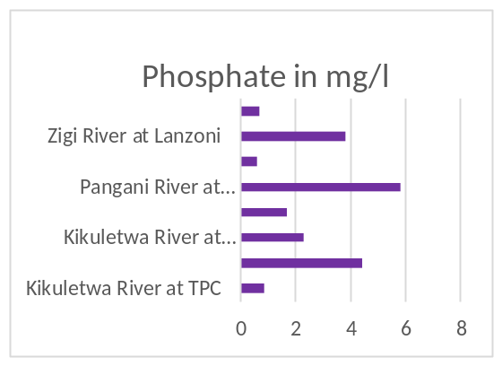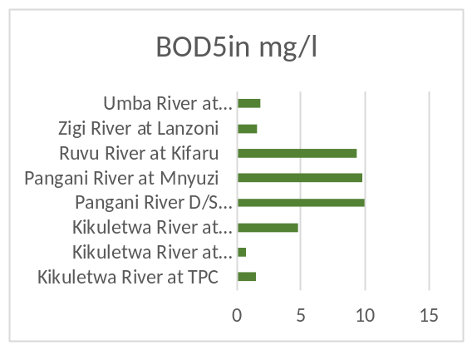
Figure 3.6.1: The highest parameters recorded

Table 3.6.1: The standard/guideline of parameters recorded
Paramaters | Unit | Standards/Guidelines Used
Paramaters | Unit | A | B | C
BOD₅ | mg/l | <2 | 5 | N.M
Phosphate | mg/l | 0.005-0.02 | N.M | 2.2

NB:
A. Natural Range of water quality from -Guidelines for Water Resources Monitoring and Pollution Control 2012
B. Tanzania Standard for Receiving Water Bodies Category 2 (TZS 2068: 2017)
C. East Africa Standard for Portable Natural Water (EAS 12: 2018)
D. NM-Not Mentioned

CONCLUSION, RECOMMENDATION AND CHALLENGES

  - Conclusion
The Pangani Basin Water Board is pleased to prepare the Annual Hydrological Report (November 2024 to October 2025) which provides insight to stakeholders to understand the general status of water resources in the Basin. Based on the data collected and analysis carried out, the basin situation in terms water availability may be rated to range from dry to average condition for the hydrological year ending October 2025.
  - Recommendation
The Board will continue to collaborate with all interested parties/partners within and outside the basin to protect the water resources and invest on infrastructures (especially monitoring stations) to ensure sustainable quality and quantity of water resources. Currently our target is to prepare and implement Integrated Water Resources management and Development (IWRMD) Plan which will provide information of available water resources and demand by sector-wise. Also the plan will help to identify all stakeholders available in the basin and how we (Basin) can engage them in sustainable water resources management. All these efforts (including the Plan preparation) will minimize water related challenges like impacts of climate change (droughts and floods), water use conflicts, water sources degradation/encroachment, etc. Therefore the Board is pleased to submit Annual Basin Hydrological Report for the period of November 2024 to October 2025.
  - Challenges and Intervention
The major challenge is lack of IWRMD Plan. Currently our target is to prepare and implement IWRMD Plan which will provide information of available water resources and demand by sector-wise. Also, the plan will help to identify all stakeholders available in the basin and how we (Basin) can engage them is sustainable water resources management. All these will minimize water related challenges like impacts of climate change (droughts and floods), water use conflicts, water sources degradation/encroachment, etc.

ANNEXES

  - Strategic location of Water Quality Stations
No. | Parameter | Kikuletwa River at TPC | Kikuletwa River at Power station | Kikuletwa River at Karangai | Pangani River D/S NYM Dam (1D8C) | Pangani River at Mnyuzi | Ruvu River at Kifaru | Zigi River at Lanzoni | Umba River at Mwakijembe
1 | pH | 7.5 | 7.4 | 8.5 | 7.8 | 8.4 | 7.6 | 7.43 | 8.1
2 | Color | 18 | 15 | 250 | 30 | 210 | 152 | 20 | 120
3 | Turbidity | 16 | 2.5 | 150 | 8 | 85.6 | 26 | 3 | 130
4 | E.C | 950 | 1240 | 372 | 1110 | 980 | 648 | 118.6 | 1500
5 | TSS | 16 | 1.2 | 13 | 13 | 22 | 17 | 0.8 | 60
6 | TDS | 475 | 620 | 186 | 550 | 490 | 324 | 59 | 750
7 | Chloride | 23.5 | 180 | 8.6 | 50.1 | 54 | 38 | 48 | 138.9
8 | BOD5 | 1.5 | 0.77 | 4.8 | 10 | 9.8 | 9.4 | 1.6 | 1.86
9 | Nitrate | 2.5 | 4.1 | 7.5 | 8 | 8.7 | 3.7 | 4.85 | 5.8
10 | Phosphate | 0.85 | 4.42 | 2.3 | 1.7 | 5.8 | 0.6 | 3.8 | 0.68
11 | Sulphate | 33.7 | 32 | 12.5 | 21 | 46 | 10 | 16 | 24
12 | FC | 14 | 310 | 420 | 138 | 600 | 142 | 25 | 96
13 | TC | 8 | 480 | 17800 | 310 | 1450 | 405 | 92 | 132
14 | Floride | 4.2 | 0.7 | 3.15 | Nd | Nd | Nd | Nd | Nd

  - Rainfall Station Summary
No. | Code | Name | Type | Lat. | Long. | Altitude | Status | Materials
1 | 9438040 | Kalimawe | Automatic | -4.417 | 38.083 | 490 | Not operating | DAVIS
2 | New | Naberera | Automatic | -3.454 | 36.533 | 1412 | Not operating | DAVIS
3 | 9438068 | Mlalo Pr. School | Manual | -4.633 | 38.417 | 455 | Operating | -
4 | 9538010 | Hale Plantation | Manual | -5.300 | 38.617 | 183 | Operating | -
5 | 9538040 | Maji Korogwe | Manual | -5.150 | 38.467 | 259 | Operating | -
6 | 9539020 | Tanga Maji | Manual | -5.083 | 39.117 | 342 | Operating | -
7 | New | Segera C. Tank | Manual | -5.300 | 38.367 | 456 | Operating | -
8 | 933718 | Kilifi Mazola Primary School | Manual | -4.396 | 37.981 | 287 | Operating | -
9 | 9538077 | Kwedilomba | Manual | -5.533 | 38.417 | 567 | Operating | -
10 | 9538078 | Mzeri Ranch | Manual | -5.167 | 38.117 | 786 | Operating | -
11 | 953817 | Hale Rainfall | Manual | -4.349 | 37.409 | 567 | Operating | -
12 | 9337005 | Kibosho Mission | Manual | -3.250 | 37.317 | 1478 | Operating | -
13 | 9337006 | Rombo Mission | Manual | -3.200 | 37.600 | 1433 | Operating | -
14 | 9337031 | Himo Sisal Estate | Manual | -3.467 | 37.550 | 960 | Operating | -
15 | 9337048 | Mowo Pr. School | Manual | -3.417 | 37.417 | 1123 | Operating | -
16 | 9337078 | Kibongoto Hospital | Manual | -3.200 | 37.117 | 1249 | Operating | -
17 | 9337098 | Maji Moshi | Manual | -3.350 | 37.333 | 840 | Operating | -
18 | 9337099 | Makeresho Pr. School | Manual | -3.183 | 37.250 | 1554 | Operating | -
19 | 9437004 | Suji Mission | Manual | -4.317 | 37.900 | 1370 | Operating | -
20 | 9337151 | Kiungu Pr. School | Manual | -5.300 | 37.267 | 1257 | Operating | -
21 | 933715 | Malilo Primary school | Manual | -3.250 | 37.317 | 1023 | Operating | -
22 | 9337116 | Uru west | Manual | -4.283 | 37.567 | 1342 | Operating | -
23 | 9337121 | Osaki forest | Manual | -3.183 | 37.250 | 1234 | Operating | -
24 | 9337143 | Nafco Kahe | Manual | -3.350 | 37.333 | 1203 | Operating | -
25 | 933712 | Kilema forest | Manual | -5.300 | 37.267 | 1155 | Operating | -
26 | New | Huruma Town | Manual | -3.350 | 37.333 | 975 | Operating | -
27 | 9336039 | Maji Arusha | Manual | -3.383 | 36.683 | 1402 | Operating | -
28 | 9336055 | Arusha Themi Water Work | Manual | -3.333 | 36.717 | 1416 | Operating | -
29 | 9336031 | Arusha TPRI | Manual | -3.333 | 36.617 | 1432 | Operating | -
30 | 9337115 | Kilimanjaro Airport | Manual | -3.417 | 36.067 | 891 | Operating | -
31 | 9337028 | TPC Langasani | Manual | -3.500 | 37.317 | 701 | Operating | -
32 | 9337021 | Lyamungo | Manual | -3.23 | 37.25 | 1250 | Operating | -
33 | 9337004 | Moshi Airport | Manual | -3.167 | 37.217 | 1234 | Operating | -
34 | 9538011 | Mlingano Agromet | Manual | -5.150 | 38.900 | 183 | Operating | -
35 | 9336035 | Tengeru(M.A.T.I) | Automatic | -3.4 | 36.783 |  | Operating
36 | 9337075 | Lomwe secondary | Automatic | -3.7142 | 37.6717 |  | Operating
37 | New | Lancon Sisal | Manual | -5.0132 | 38.7994 |  | Operating

  - Meteorological/Weather station Summary
No. | Code | Name | Type | Latitude | Longitude | Altitude | Status | Materials
1 | 9438074 | Magoma | Automatic | -4.933 | 38.2563 |  | Operating | VAISALA
2 | 9438075 | Mnazi | Automatic | -4.408 | 38.2441 |  | Not operating | VAISALA
3 | 9337004 | Nyumba ya Mungu | Automatic | -3.783 | 37.450 | 810 | Operating | VAISALA
4 | 9337003 | Naururu | Automatic | -4.167 | 37.167 | 794 | Operating | VAISALA
5 | 9438076 | Lushoto | Automatic | -4.783 | 38.283 | 1400 | Not operating | VAISALA
6 | 9538079 | Handeni | Automatic | -5.433 | 38.033 | 680 | Operating | VAISALA
7 | New | Lake Chala | Automatic | -4.996 | 38.725 | 879 | Operating | VAISALA
8 | 9438009 | Buiko | Automatic | -4.65 | 38.05 |  | Operating | VAISALA
9 | New | Mareu Lutheran Church | Automatic | -3.321 | 36.974 | 1192 | Semi-Auto Operating | DAVIS
10 | New | Maroroni / Emmanuel VTC | Automatic | -3.464 | 36.876 | 1008 | Semi-Auto Operating | DAVIS
11 | New | Amani NIMR | Automatic | -5.09958 | 38.63143 |  | Semi-Auto Operating | DAVIS
12 | New | Ndoombo P/School | Automatic | -3.328 | 36.776 | 1721 | Semi-Auto Operating | DAVIS
13 | New | Songambele P/Sch./ Themi | Automatic | -3.569 | 36.811 | 980 | Semi-Auto Operating | DAVIS
14 | 9336055 | Arusha forest | Automatic | -3.31146 | 36.87224 |  | Semi-Auto Operating | DAVIS
15 | New | Mabayani | Automatic | -5.0378 | 38.9101 |  | Semi-Auto Operating | DAVIS

  - River Gauging Stations Summary
No. | Code | Name | River | Location | Type | Lat. | Long. | Status
1 | 1CA2 | Bombo River at Kwamkole | Bombo | Kwamkole | Manual | -4.981 | 38.717 | Operating
2 | New | Burka River at Muriet/Sinoni | Burka | Muriet / Sinoni | Automatic | -3.428 | 36.676 | Operating
3 | 1DC11 | Himo River at Himo | Himo | Himo | Semi-Automatic | -3.383 | 37.533 | Operating
4 | 1DB2A | Hingilili River at Ngulwi | Hingilili | Ngulwi | Semi-Automatic | -3.533 | -37.200 | Operating
5 | 1DD3 | Karanga River at Arusha-Moshi Road | Karanga | Moshi-Arusha Road | Semi-Automatic | -3.350 | 37.300 | Operating
6 | New | Kihuhwi River at Longuza Forest | Kihuhwi | Longuza Forest | Manual | -5.114 | 38.693 | Operating
7 | 1DD8A | Kikafu River at Moshi-Arusha Road | Kikafu | Moshi-Arusha Road | Semi-Automatic | -3.333 | 37.233 | Operating
8 | 1DE11 | Kikuletwa River at Wahoga Chini | Kikuletwa | Wahoga Chini | Manual | -3.333 | 36.800 | Operating
9 | 1DD55 | Kikuletwa River at Karangai | Kikuletwa | Karangai | Automatic | -3.444 | 36.856 | Operating
10 | 1DD54 | Kikuletwa River at Power Station | Kikuletwa | Power Station | Semi-Automatic | -3.458 | 37.292 | Operating
11 | 1DD1 | Kikuletwa River at TPC | Kikuletwa | TPC | Semi-Automatic | -3.517 | 37.283 | Operating
12 | 1D1A | Luengera River at Korogwe | Luengera | Korogwe | Semi-Automatic | -5.133 | 38.575 | Operating
13 | 1DA3 | Luengera River at Magoma | Luengera | Magoma | Semi-Automatic | -4.872 | 38.567 | Operating
14 | New | Lumi River at Ungwasi | Lumi | Ungwasi | Semi-Automatic | -3.633 | 37.678 | Operating
15 | 1DD31A | Magdarisho River at Magdarisho | Magdarisho | Magdarisho | Semi-Automatic | -3.372 | 36.853 | Operating
16 | New | Makisoru / Manyire River at Manyire | Makisoru / Manyire | Manyire | Automatic | -3.457 | 36.832 | Operating as semi-automatic
17 | 1DD50 | Malala River at Malala | Malala | Malala | Automatic | -3.392 | 36.817 | Operating
18 | New | Malala River at Nkoavele | Malala | Nkoavele | Manual | -3.342 | 37.806 | Operating
19 | New | Mayi ya Chai River at Mayi ya Chai | Mayi ya Chai | Mayi ya Chai | Automatic | -3.370 | 36.894 | Operating as semi-automatic
20 | 1BA1 | Mbalamo River at Kivingo | Mbalamo | Kivingo | Semi-Automatic | -4.417 | 38.433 | Operating
21 | 1DC23 | Miwaleni River at Miwaleni Spring | Miwaleni | Miwaleni Spring | Semi-Automatic | -3.475 | 36.756 | Operating
22 | 1DB17 | Mkomazi River at Gomba | Mkomazi | Gomba | Semi-Automatic | -5.022 | 38.279 | Operating
23 | 1DB20 | Mkomazi River at Makayo | Mkomazi | Makayo | Manual | -4.639 | 38.071 | Operating
24 | 1C5 | Mkulumuzi River at Upare | Mkulumuzi | Upare | Semi-Automatic | -3.536 | 37.758 | Operating
25 | 1DB22 | Mkusu River at Kibohero | Mkusu | Kibohero | Semi-Automatic | -4.729 | 38.286 | Operating
26 | 1DC6 | Mue River at Kahe/Taveta Railway Bridge | Mue | Kahe/Taveta Railway Bridge | Manual | -3.883 | 37.467 | Operating
27 | New | Muzi River at Msakazi | Muzi | Msakazi | Manual | -4.981 | 38.717 | Operating
28 | New | Nduruma River at Mlangarini | Nduruma | Mlangarini | Automatic | -3.457 | 36.792 | Operating as semi-automatic
29 | 1DD20A | Nduruma River at Moshi-Arusha Road | Nduruma | Moshi-Arusha Road | Semi-Automatic | -3.375 | 36.758 | Operating
30 | New | Nduruma River at Nkoamala | Nduruma | Nkoamala | Semi-Automatic | -3.633 | 36.825 | Operating
31 | 1DD47A | Ngaresero River at Usa | Ngaresero | Usa | Semi-Automatic | -3.372 | 36.850 | Operating
32 | 1DC35 | Njoro River at Njoro Forest | Njoro | Njoro Forest | Semi-Automatic | -3.358 | 37.349 | Operating
33 | 1D10 | Pangani River at Buiko | Pangani | Buiko | Semi-Automatic | -4.650 | 38.042 | Operating
34 | 1D14 | Pangani River at Korogwe | Pangani | Korogwe | Semi-Automatic | -5.167 | 38.467 | Operating
35 | 1D16 | Pangani River at Magunga | Pangani | Magunga | Manual | -5.191 | 38.542 | Operating
36 | 1D17 | Pangani River at Mnyuzi | Pangani | Mnyuzi | Semi-Automatic | -5.291 | 38.475 | Operating
37 | 1D18 | Pangani River at Naururu | Pangani | Naururu | Semi-Automatic | -4.167 | 37.533 | Operating
38 | 1DC5A | Rau River at Moshi-Himo Road | Rau | Moahi-Himo Road | Semi-Automatic | -3.350 | 37.383 | Operating
39 | 1DC2A | Ruvu River at Kifaru | Ruvu | Kifaru | Semi-Automatic | -3.525 | 37.467 | Operating
40 | 1DB2A | Saseni River at Gulutu | Saseni | Gulutu | Semi-Automatic | -4.583 | -38.344 | Operating
41 | 1C1 | Sigi River at Kisiwani | Sigi | Kisiwani | Semi-Automatic | -3.372 | -36.850 | Operating
42 | 1C1 | Sigi River at Lanconi | Sigi | Lanconi | Semi-Automatic | -5.014 | 38.800 | Operating
43 | 1C2 | Sigi River at Miembeni | Sigi | Miembeni | Semi-Automatic | -4.996 | 38.725 | Operating
44 | 1DB19 | Soni River at Soni | Soni | Soni | Semi-Automatic | -4.838 | 38.371 | Operating
45 | New | Tengeru River at Lekitatu / Lake Tatu | Tengeru | Lekitatu / Lake Tatu | Automatic | -3.422 | 36.851 | Operating as semi-automatic
46 | 1DD24A | Tengeru River at Tengeru | Tengeru | Tengeru | Automatic | -3.633 | 36.825 | Operating
47 | 1DE | Themi River at Njiro | Themi | Njiro | Manual | -3.375 | 36.858 | Operating
48 | New | Themi River at Urangini | Themi | Urangini | Automatic | -3.546 | 36.785 | Operating as semi-automatic
49 | 1B1A | Umba River at Mlalo | Umba | Mlalo | Semi-Automatic | -4.583 | 38.344 | Operating
50 | 1B4A | Umba River at Mwakijembe | Umba | Mwakijembe | Semi-Automatic | -4.514 | 38.892 | Operating
51 | 1DD26 | Usa River at Dolly Sisal Estate | Usa | Dolly Sisal Estate | Automatic | -3.403 | 36.864 | Operating
52 | 1DD35 | Usa River at Usa | Usa | Usa | Semi-Automatic | -3.403 | 36.864 | Operating
53 | 1DD5A | Weruweru River at Railway Bridge | Weruweru | Railway Bridge | Semi-Automatic | -3.150 | 37.267 | Operating
54 | New | Zigi River at Longuza Forest | Zigi | Longuza Forest | Manual | -5.119 | 38.691 | Operating
55 | New | Njoro Maimai at Komolo | Njoro | Komolo | Manual |  |  | Operating
56 | New | Ngarenaro at Shiboro | Ngarenaro | Shiboro | Manual |  |  | Operating
57 | 1E1 | Msangazi at Kwedilomba | Msangazi | Kwedilomba | Manual |  |  | Operating
58 | 1C6 | Msimbazi at Lugongo | Msimbazi | Lugongo | Semi-Automatic | -4.876 | 38.81372 | Operating
59 | 1D8C | Pangani at Nyumba ya Mungu | Pangani | Nyumba ya Mungu | Semi-Automatic | -3.84024 | 37.46003 | Operating

  - Groundwater Monitoring Stations
No. | Name of BH | Location | Depth (m) | Static water  level (m) | Altitude | Yield (m³/h)
1 | Sinoni | Arusha | 58 | 2.26 | 1268 | 4
2 | Kambi ya Tanga | Arusha | 64 | 15.85 | 939 | 16.7
3 | Magereza | Arusha | 96 | 42.64 | 1382 | 18
4 | Sido | Kilimanjaro | 60 | 17.40 | 812 | 17.9
5 | Sanya juu | Kilimanjaro | 49 | 19.38 | 1374 | 1.5
6 | Magereza | Kilimanjaro | 75 | 26.8 | 972 | 18
7 | Mabogini | Kilimanjaro | 62 | 8.31 | 673 | 17.9
8 | Kaloleni | Kilimanjaro | 65 | 7.34 | 782 | 17.4
9 | Makayo | Tanga | 50 | 1.49 | 448 | 18.8
10 | Korogwe | Tanga | 50 | 8.5 | 309 | 18.4
11 | Pangani | Tanga | 60 | 27.02 | 75 | 1.59

Hydrological year Book, 2010-2019, Vol 1, March 2019

